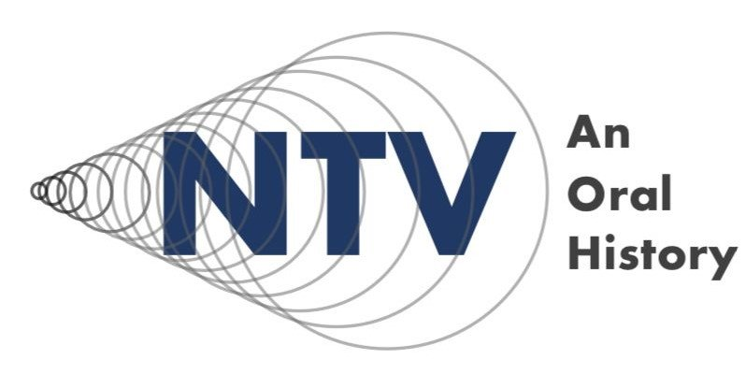

Nuclear Test Veterans: An Oral History
Teaching Pack

Introduction
This teaching pack has been designed to support educators to bring the oral histories, essays and images of the ‘Nuclear Test Veterans, An Oral History’ project to life in the classroom.
The pack consists of:
- This Introduction
- Classroom slides for three workshops
- Accompanying teaching notes for three workshops.
- Resources for the workshops
- Useful links - additional reading and resources
- Simple evaluation tools (optional)
The oral histories, essays and images collected by the University of Liverpool & the University of South Wales through their research are held on the British Library website [ADD LINK] as part of their ‘Untold Lives’ collection.

Within this document you can find:

Project Overview Page 2
Context Page 3
Overview of the Workshops Page 5
A Note on Evaluation Page 6
Project Partners Page 7
Project Overview
After 70 years of government denial that radiation harm was suffered by servicemen during the British nuclear test programme (1952-67), the nuclear test veteran community are calling for their voices and stories to be heard and for deeper public understanding of their experiences to be achieved. The project which has inspired these resources was funded by the Office for Veterans’ Affairs (OVA). This teaching pack aims to meet the challenge of creating impactful resources that fully reveal the rich potential of a high-profile oral history project.
Nuclear test veterans have repeatedly told the OVA team about the importance they place on education. The workshops and resources that form this teaching pack can be used across Key Stages 3-5. The nature of the participatory and dialogue-based activities within is such that young people can meet the historical sources and related information where they are, at a depth defined by them.
Various themes arising from the collection of nuclear test veterans’ oral histories are explored within the workshops, including recognition for service, exposure to radiation, social impact on veterans & their families, environmental impact, impact on indigenous communities, international relations, the Cold War and more.
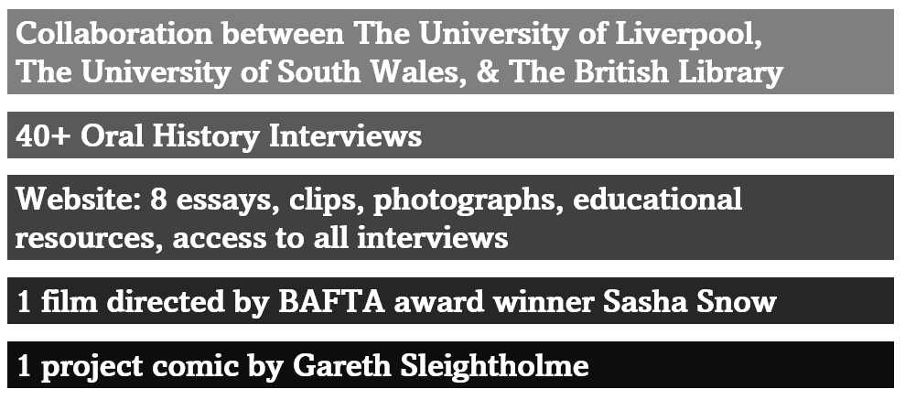

Context
The veterans interviewed were all part of Operation Grapple. Operation Grapple saw a series of British nuclear weapons tests carried out off the coast of Kirimati, an island in the Pacific Ocean, between 1957 and 1958. At that time, Kirimati was known as Christmas Island and was part of the British Gilbert and Ellice Islands Colony.
The oral histories highlight a range of themes relating to nuclear testing, including:
Health – many veterans feel that the health of themselves and their children has been significantly impacted by being exposed to radiation. The science is inconclusive, however the government has withheld medical records from many of the servicemen who took part. In addition, the mental health of many of those who were part of Operation Grapple has been impacted, including due to ongoing concerns about the physical health effects, for them and their children. Work undertaken by scientists such as those at Brunel University does not conclusively prove or disprove theories around the health implications.
Government secrecy – in addition to withholding access to medical records, in many cases, servicemen did not know what they were going to Christmas Island for. Anecdotes such as higher-ranking officers being given full protective equipment, whilst soldiers and airmen were not, add to the feeling that the government knew and know more than they want to admit about the potential impact of taking part in the Grapple tests.
Indigenous communities – peoples who were living on Kirimati at the time of Operation Grapple were colonial subjects of Britain. They were unable to make choices about being witness to nuclear bomb tests, or about the use of their land as a testing ground. Islanders would also be susceptible to any health impacts and had to continue to live from the land after the tests were finished (and after the Gilbert & Ellice Islands Colony (GEIC) gained independence as two separate states on 1st January 1976). What was the GEIC is now the two separate states of Tuvalu and Kiribati.
Environmental impact – whilst the impact of nuclear testing on local ecosystems is unproven, and denied by many in authority, there are many anecdotes about depleted fish populations, ‘nuclear rain’, and concern about the safety of crops grown near detonation sites. What is certain is that the military left significant detritus around the island when testing was finished, and that the historical relationships of Pacific islanders with their natural environment would have been disrupted by Operation Grapple and similar actions.

There are ongoing campaigns for recognition for the contribution of the veterans who took place in nuclear bomb testing (not only Operation Grapple but other tests – see below). From demands to acknowledge health impacts, requests for formal recognition (some veterans have now been awarded the Nuclear Test Medal, some after waiting for more than seventy years), and requests for compensation (Many other countries have awarded blanket financial compensation to those who took part in nuclear weapons tests).

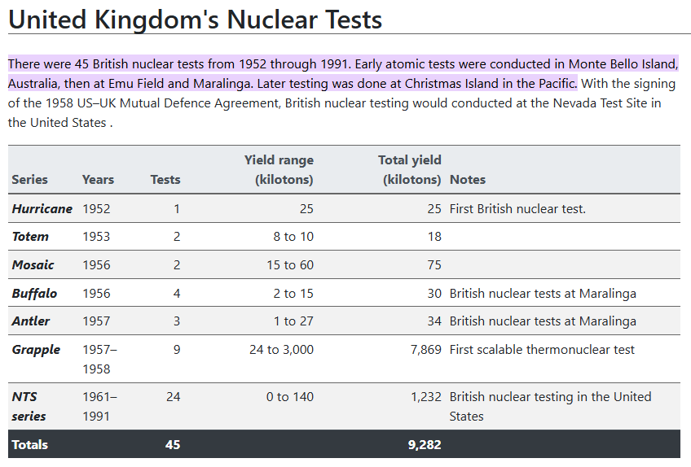
Table taken from atomicarchive.com

Overview of Workshops
Pre-Workshop
- Watch the ‘Nuclear Test Veterans, An Oral History’ film (INSERT LINK)
- Read the ‘Nuclear Test Veterans, An Oral History' comic book (INSERT LINK)

Workshop 1: An Introduction to Nuclear Bomb Testing
Evaluation Wheel (Optional) | Getting a baseline indication of student knowledge
Comic Book | Warm up activity
Photo Voice | Inspiring curiosity / meeting some of the sources
Nuclear Thought Bubbles | Activating existing knowledge
Brief History of Nuclear Testing | Expanding knowledge
Continuum Lines | Eliciting values & Opinions
Workshop 2: Oral Histories
Listening Triads | Developing active listening skills
Oral Histories – an example and an introduction | Expanding knowledge
The Oral History Backpack | Developing oral history skills
Creating questions for oral history work | Developing oral history skills
Workshop 3: The Impacts of Nuclear Testing
A Symbolic Exchange | Warm up / activating knowledge
Nuclear test veterans’ oral histories | Exploring the source material
Exploring Impact | Drawing out themes
Nuclear reflections | Developing empathy / linking past and present
Evaluation Wheel (optional) | Getting an endline indication of student knowledge

A Note on Evaluation – An Optional Extra
Some teachers or schools might like to measure the impact of these sessions on their pupils.
With that in mind we have included one of our simple evaluation tools in the teaching pack.
In order to be useful, the tool should be used at the beginning of the first workshop and revisited at the end of the third workshop.
See full guidance in the teaching notes for workshop one.

This teaching pack has been created by

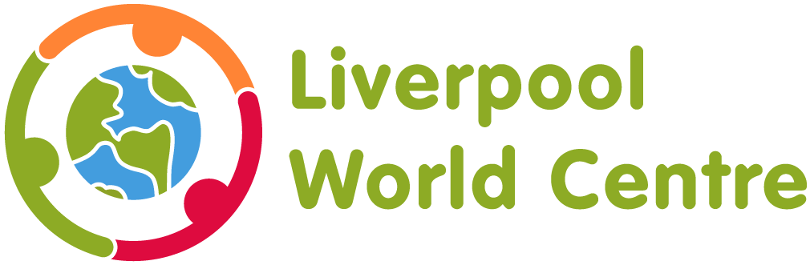

in collaboration with

